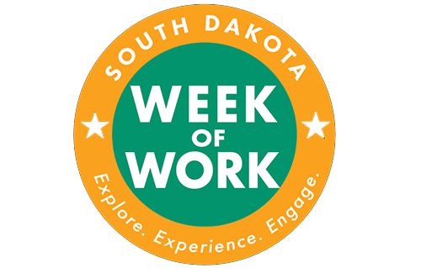
Name:___________________________________________ Date:_______________________

Panelist Name | Position / Job Title | Business / Company

Which career appealed to you the most? Why?

What were some of the job duties of the career that appealed to you?

What type of education is required?

What are at least 2 interesting take-a-ways? And/or What are at least 2 questions you have?

